**IBM NAAN MUDHALVAN**

**DOMAIN – DATA ANALYTICS WITH COGNOS**

|  |  |
| --- | --- |
| **DATE** | 01.11.2023 |
| **TEAM ID** | PROJ_224694_TEAM_2 |
| **PROJECT TITLE** | CUSTOMER CHURN PREDICTION-TELECOMMUNICATION CUSTOMER CHURN PREDICTION |

**PROBLEM:**

To predict the customers who are likely to churn in the telecom industry.

**PROBLEM DEFINITION:**

* Telecommunication companies (telco’s) have a significant problem with customer churn, which is the loss of customers who stop using their services.
* Customer churn is the percentage of customers who stopped purchasing your business's products or services during a certain period of time.
* To solve this problem, telco’s need to identify the customers who are likely to churn and take preemptive measures to retain them.

**SOLUTION:**

* Import necessary libraries and then understand the data.
* Remove inconsistent or erroneous records from the dataset – Data Cleaning.
* Perform Exploratory data Analysis (EDA) using visualization techniques.
* Predict the outcome using machine learning models like Logistic Regression, Random forest, Gradient Boost XGBoost and CatBoost.
* CatBoost(Categorical Boost) can predict extradinally faster than other models.

**STEPS IN CHURN PREDICTION:**

1. Data Exploration
2. Exploratory Data Analysis(EDA) and Data Cleaning
3. Data Visualization
4. Feature Engineering
5. Data splitting
6. Comparing different ML Models
7. Model Selection : CatBoost
8. Hyperparameter tuning
9. Check model’s performance

**DESIGN THINKING PROCESS**

**EMPATHY MAPPING:** An empathy map is a collaborative tool teams can use to gain a deeper insight into their customers.

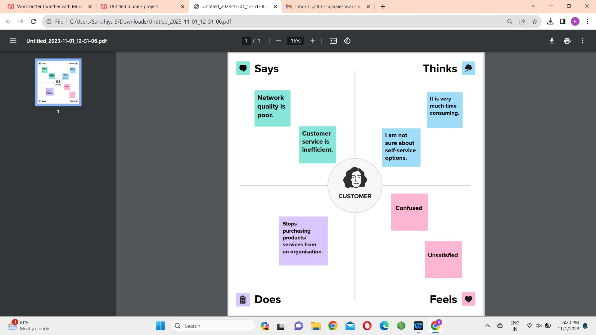

**DATA EXPLORATION:**

**Importing Packages**

Import **pandas , numpy** libraries for data handling and **matplotlib , seaborn** libraries for data visualization.

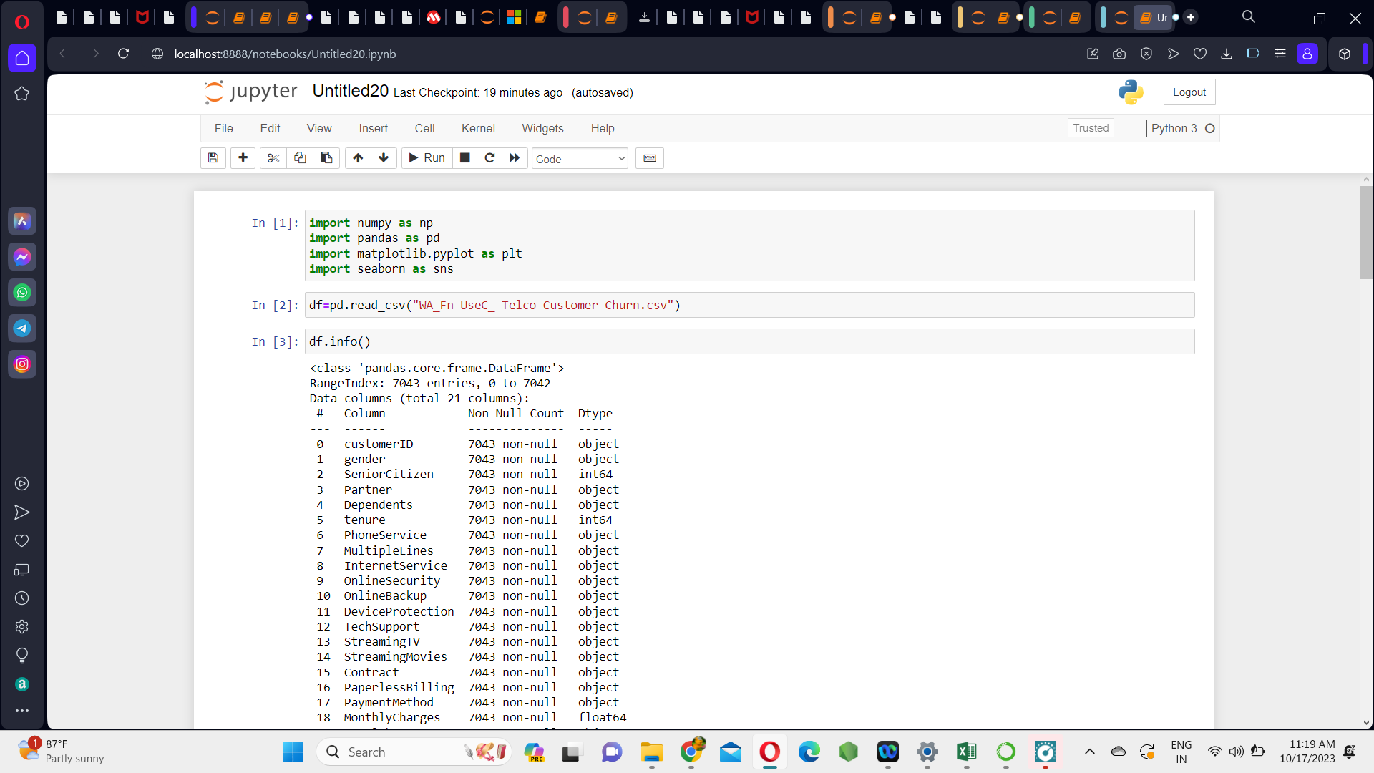

**Loading Telecom Customer Churn Dataset**

Now, load the Telecommunication churn dataset (csv file) by using the function pd.read_csv()

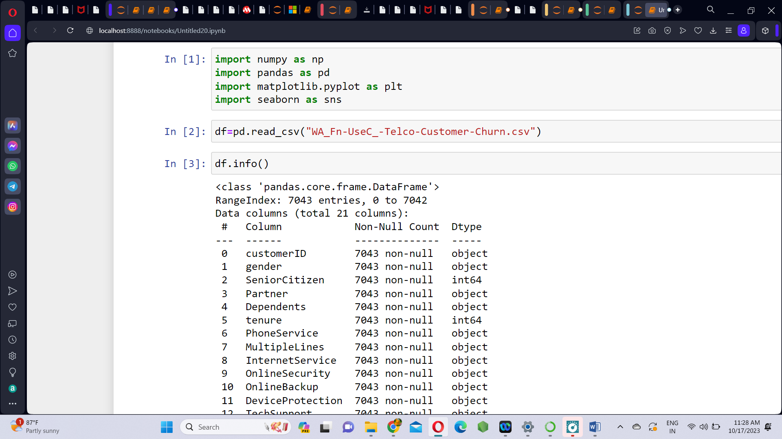

**Information about Dataset**

The dataset has 21 columns and 7043 rows. Use df.info() and df.head() functions to know about the dataset.

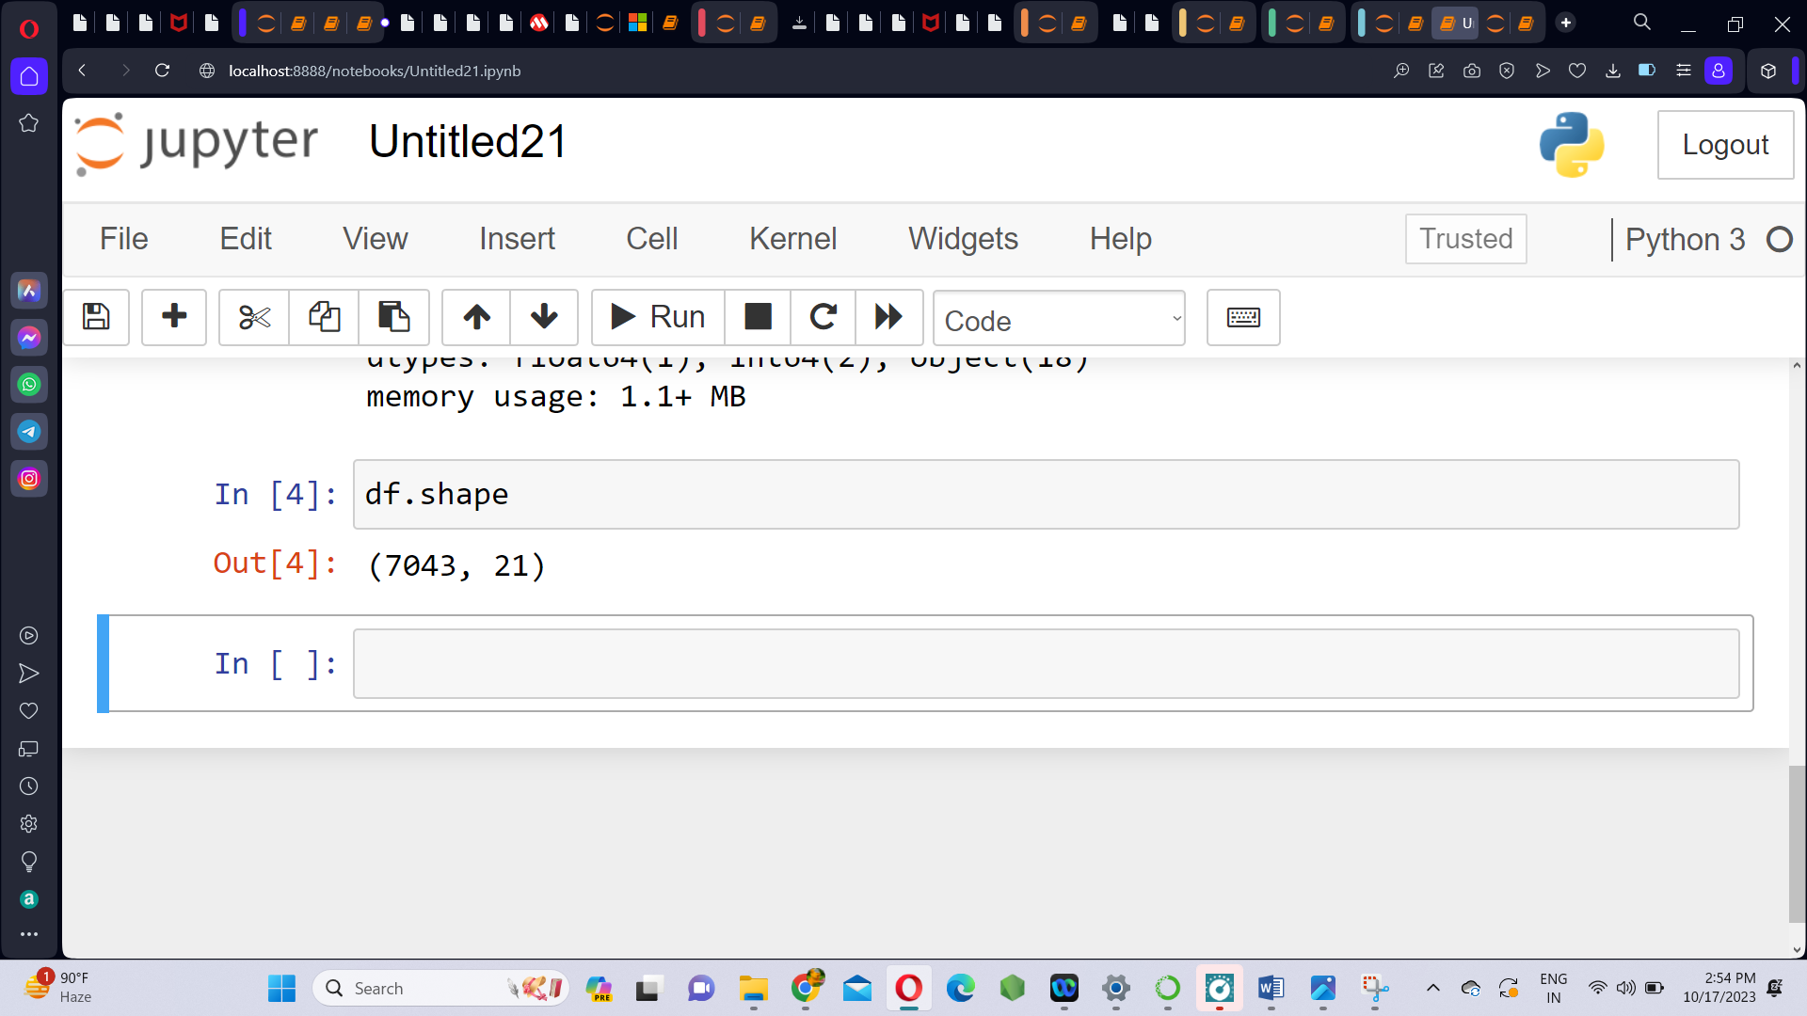

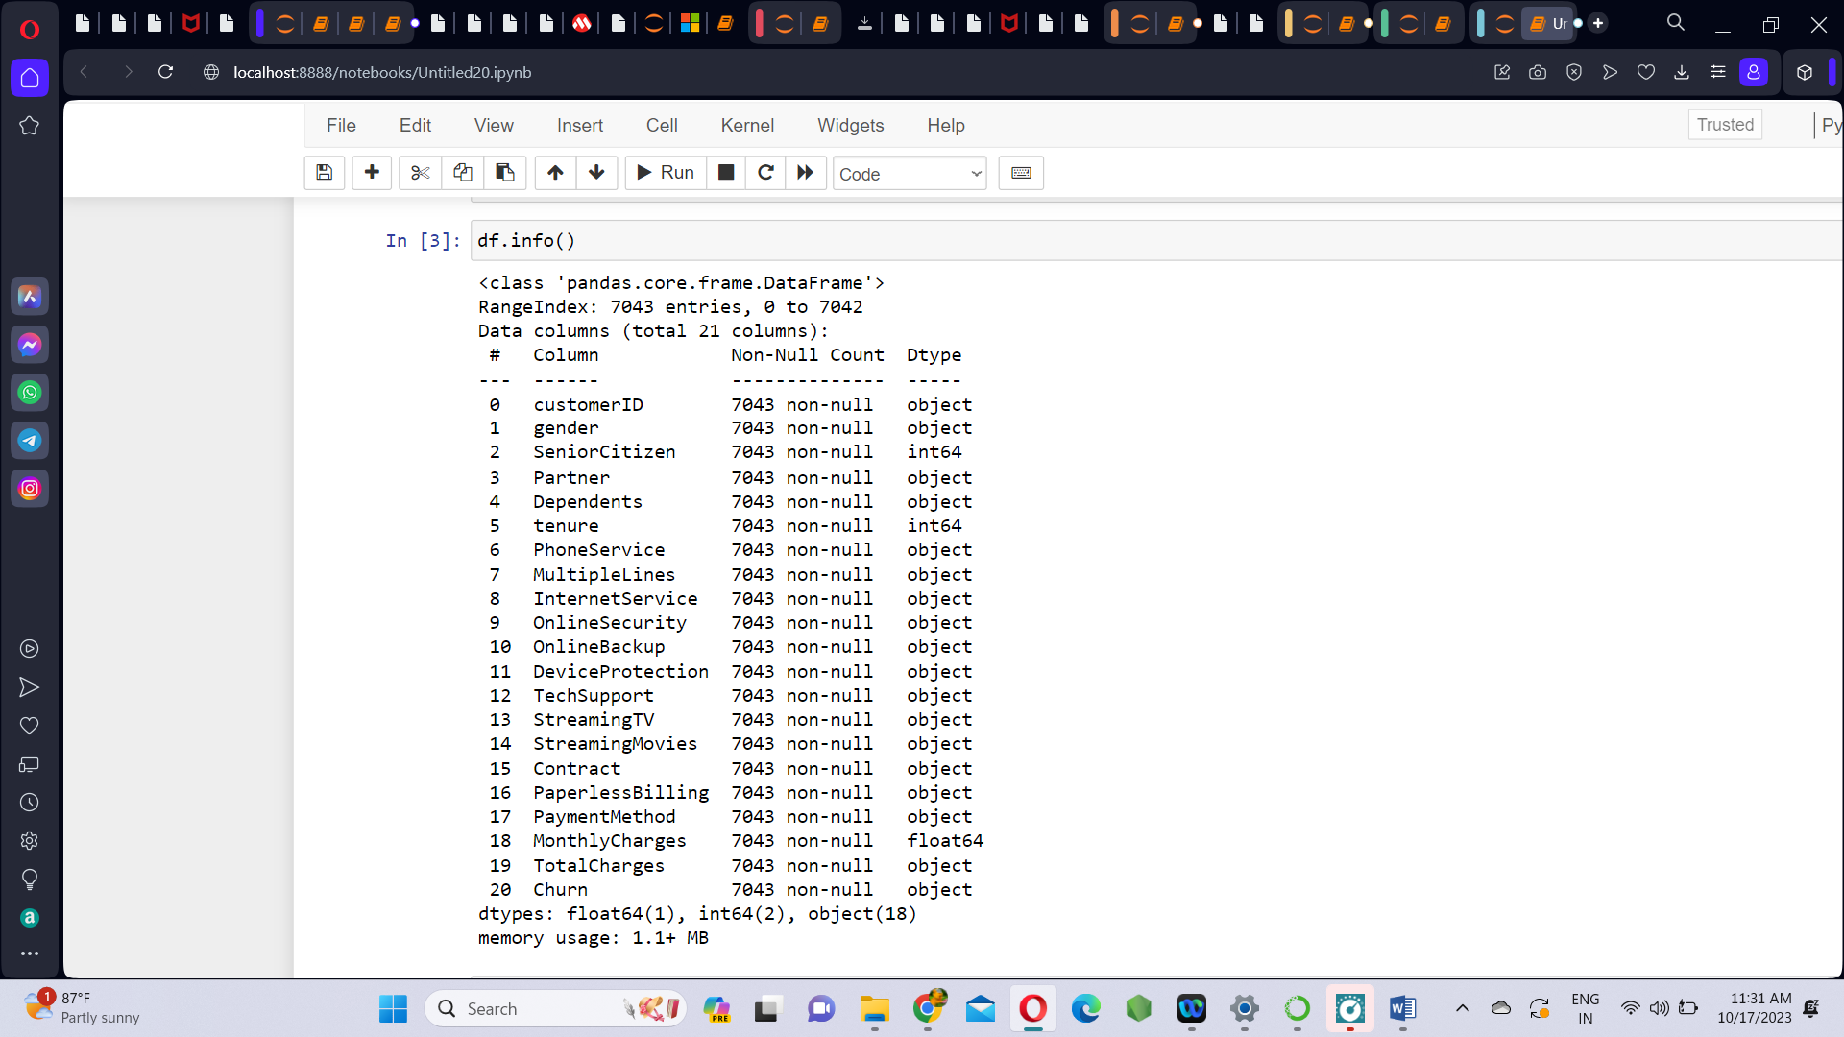

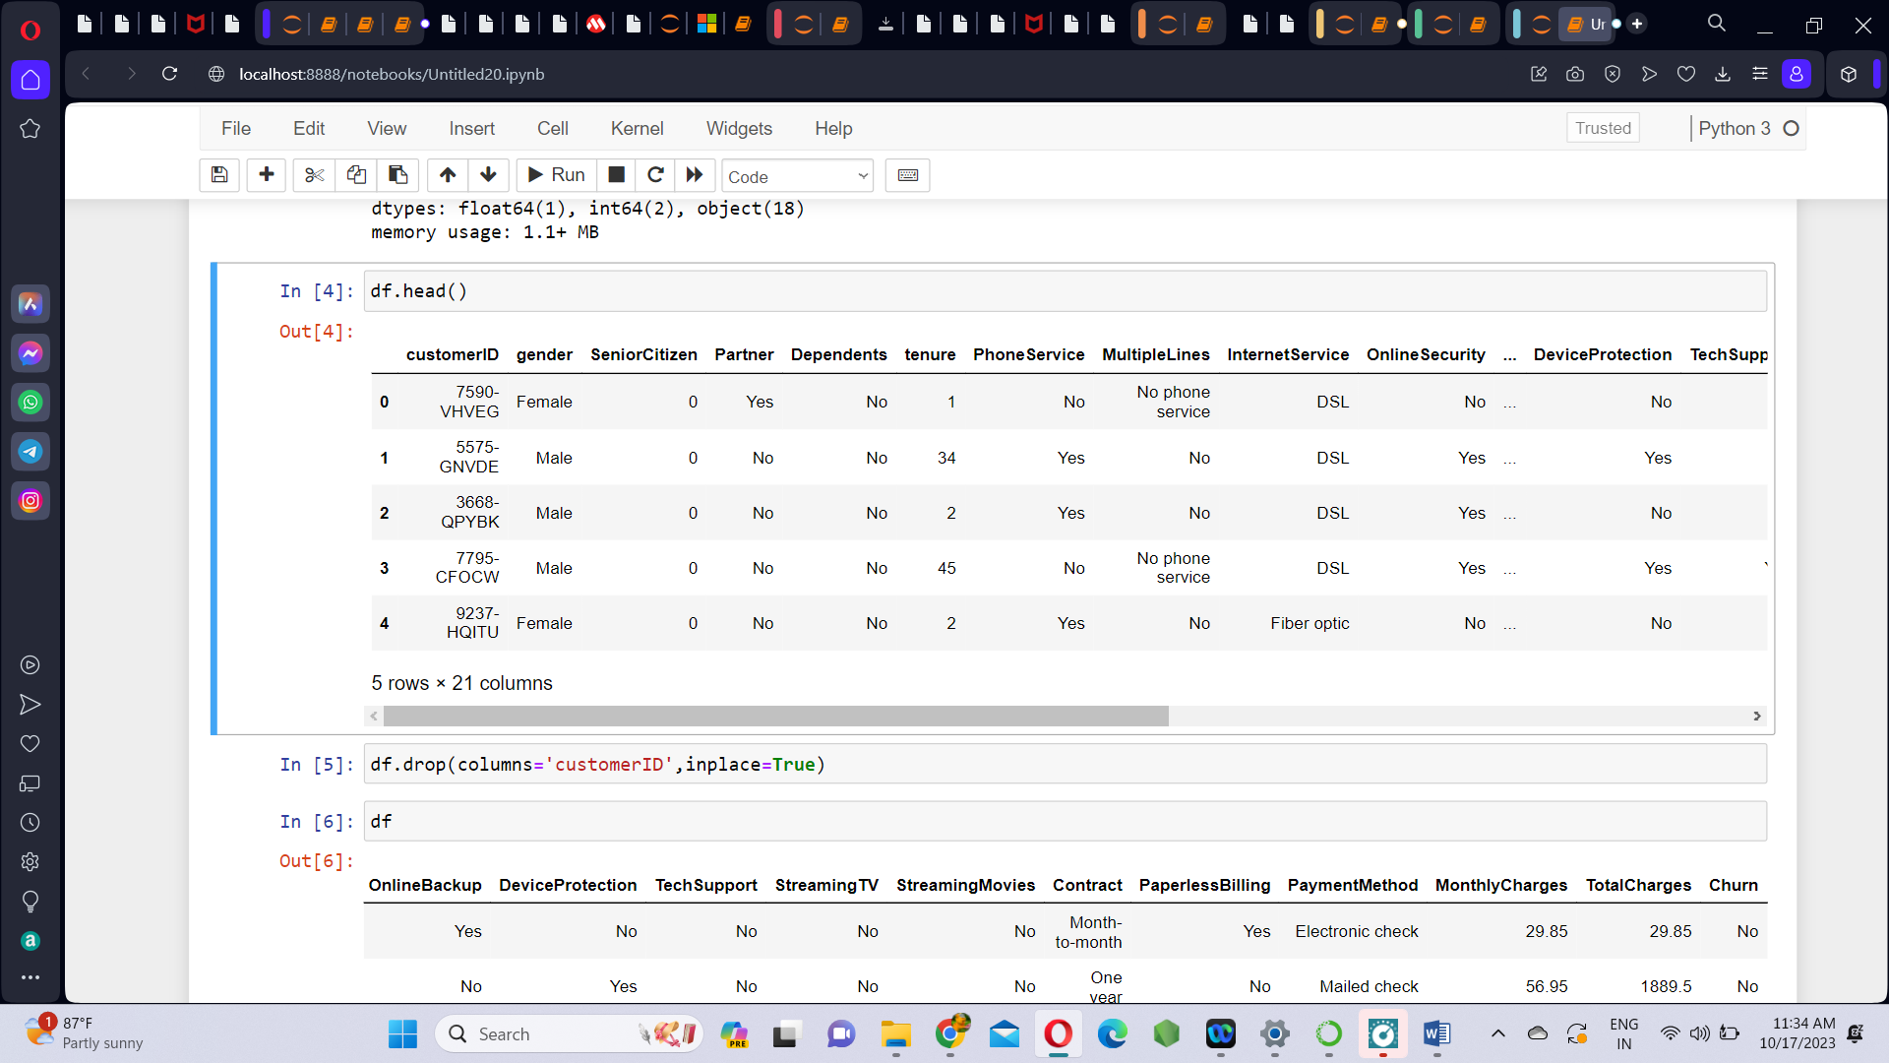

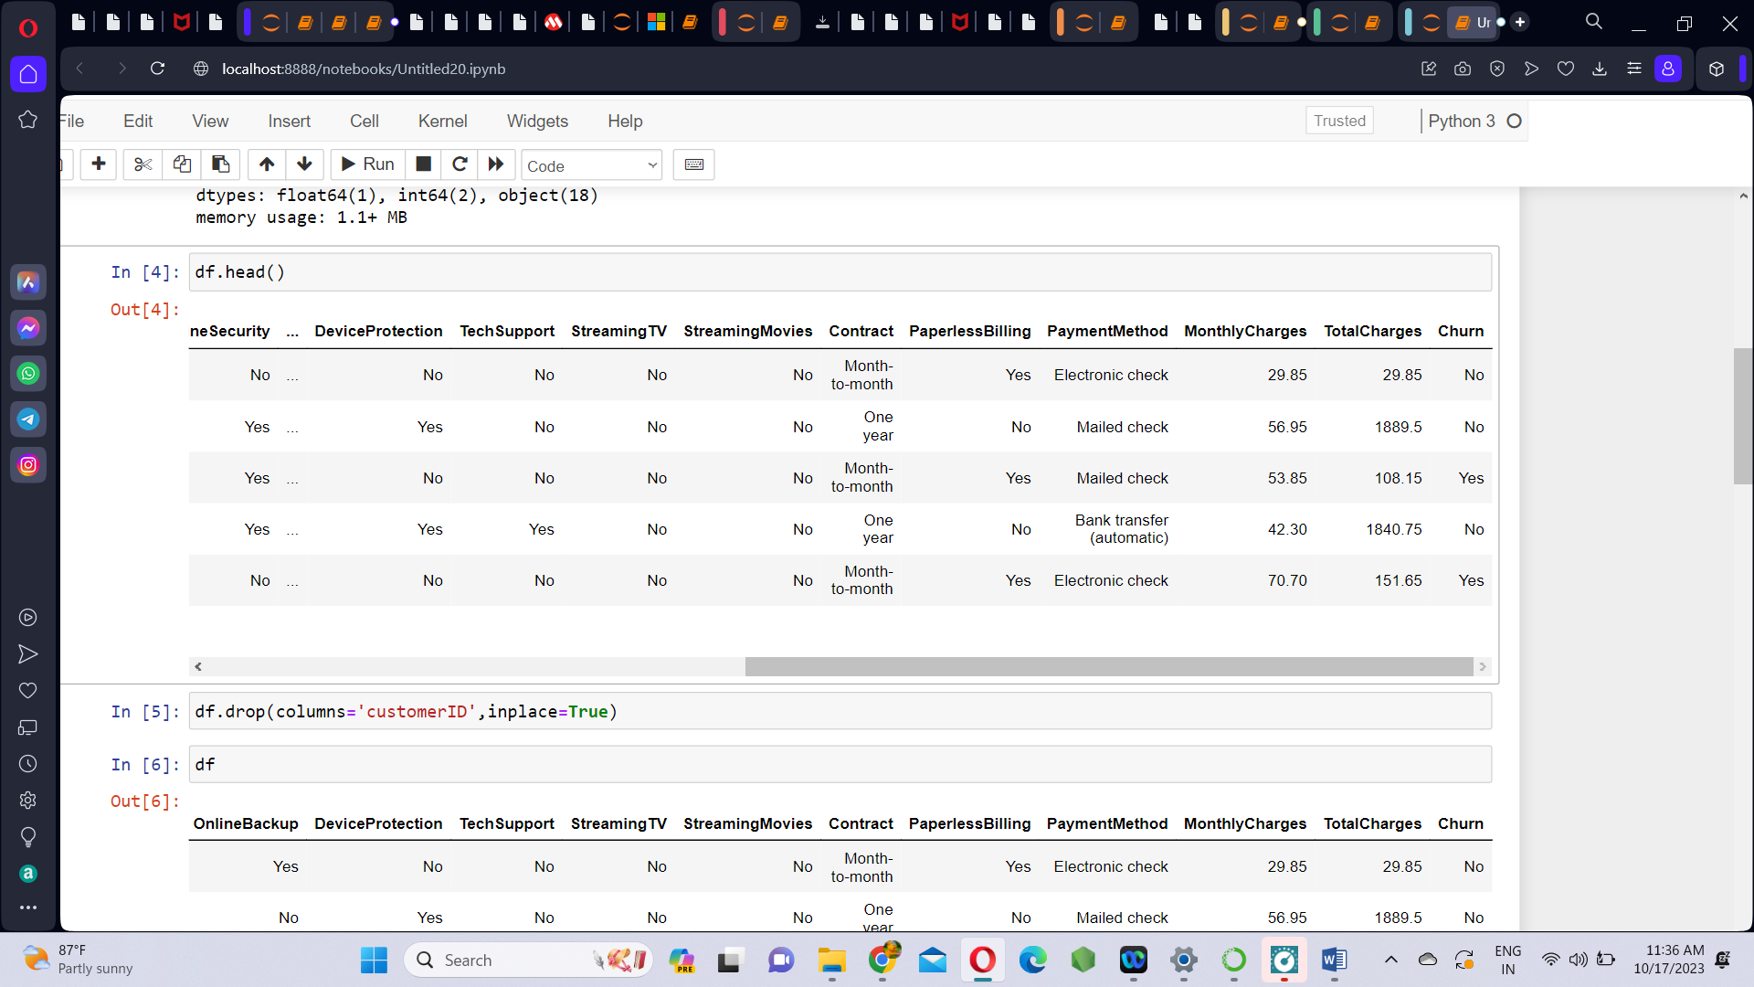

**Data Cleaning:**

1. Remove unwanted column - customer ID. As the column ‘customerID’ does not tell about whether the cutomer will churn or not. So we remove it.

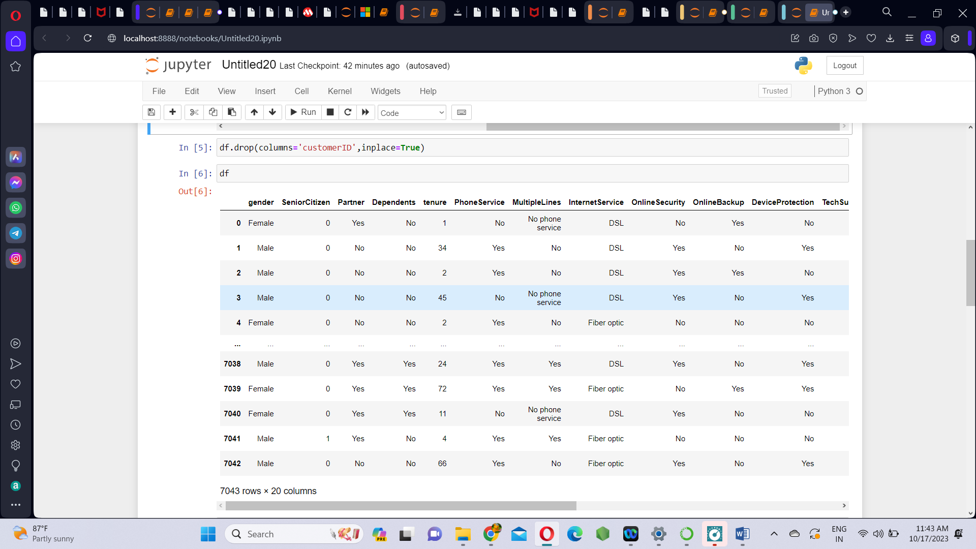

1. Check the null values using isna() function.

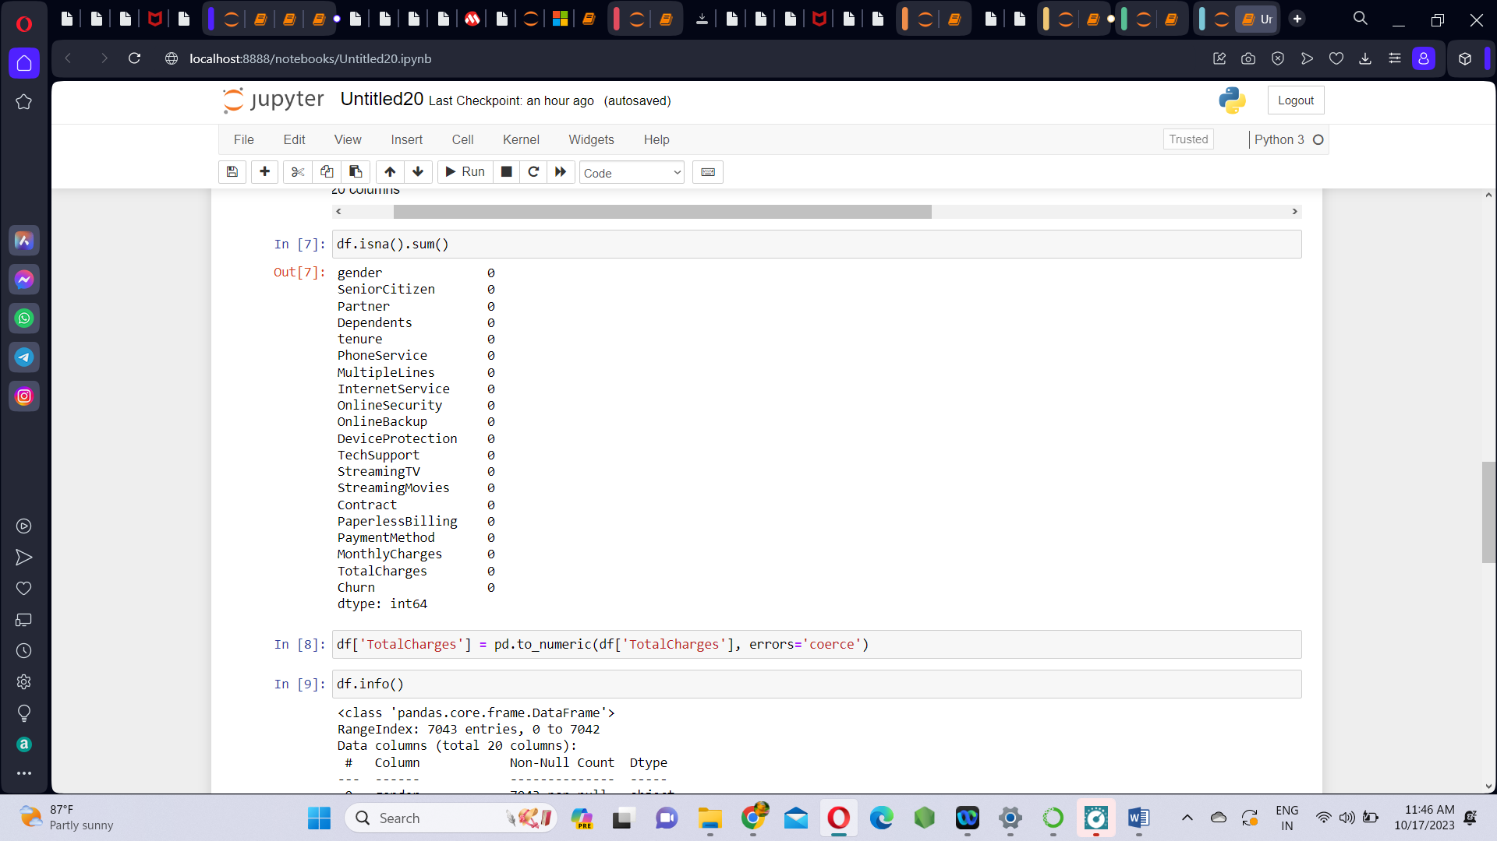

There are no null values in any of the columns of the dataset.

1. **Convert ‘TotalCharges’ from object to float datatype:**

The column ‘TotalCharges’ is actually contains float values but it is mentioned as object. So we change it into numeric.

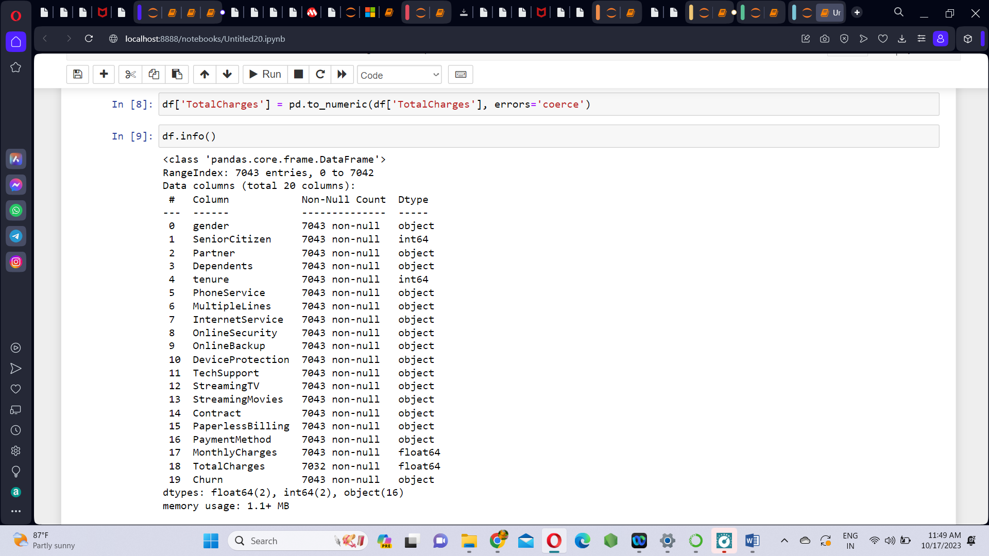

1. **Removing ‘(automatic)’ string from PaymentMethod column:**

Under the PaymentMethod column, the values Bank transfer and Credit card has (automatic) in them which is unwanted. So we replace the string ‘(automatic)’ with an empty string.

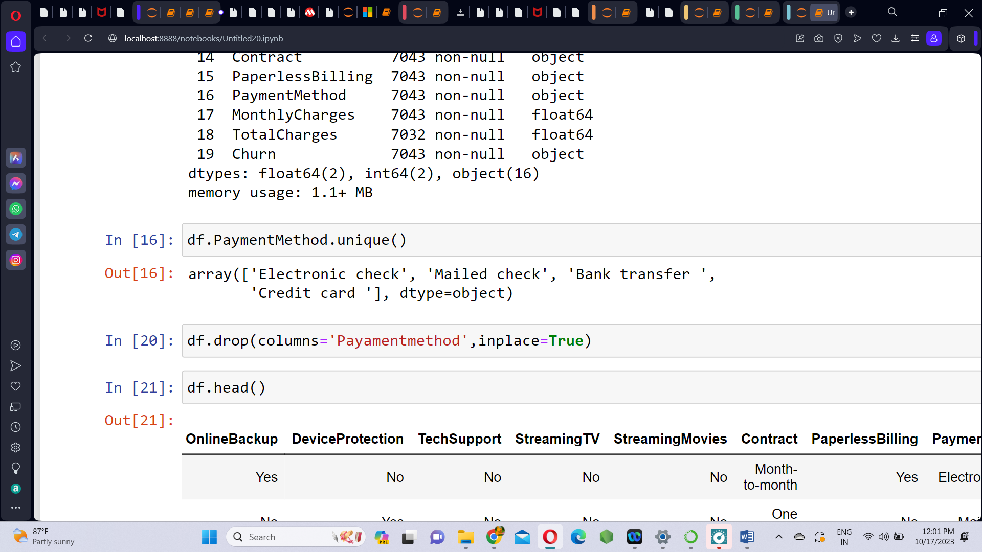

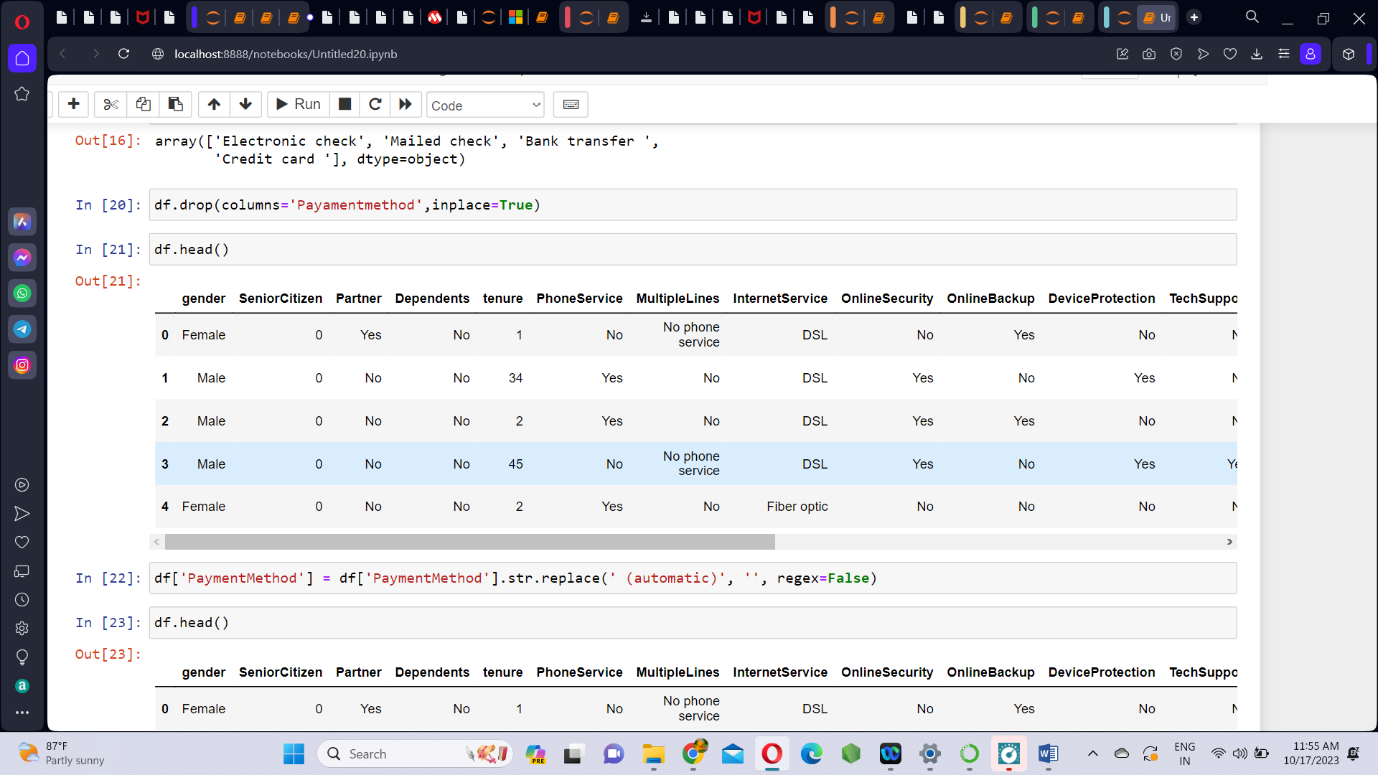

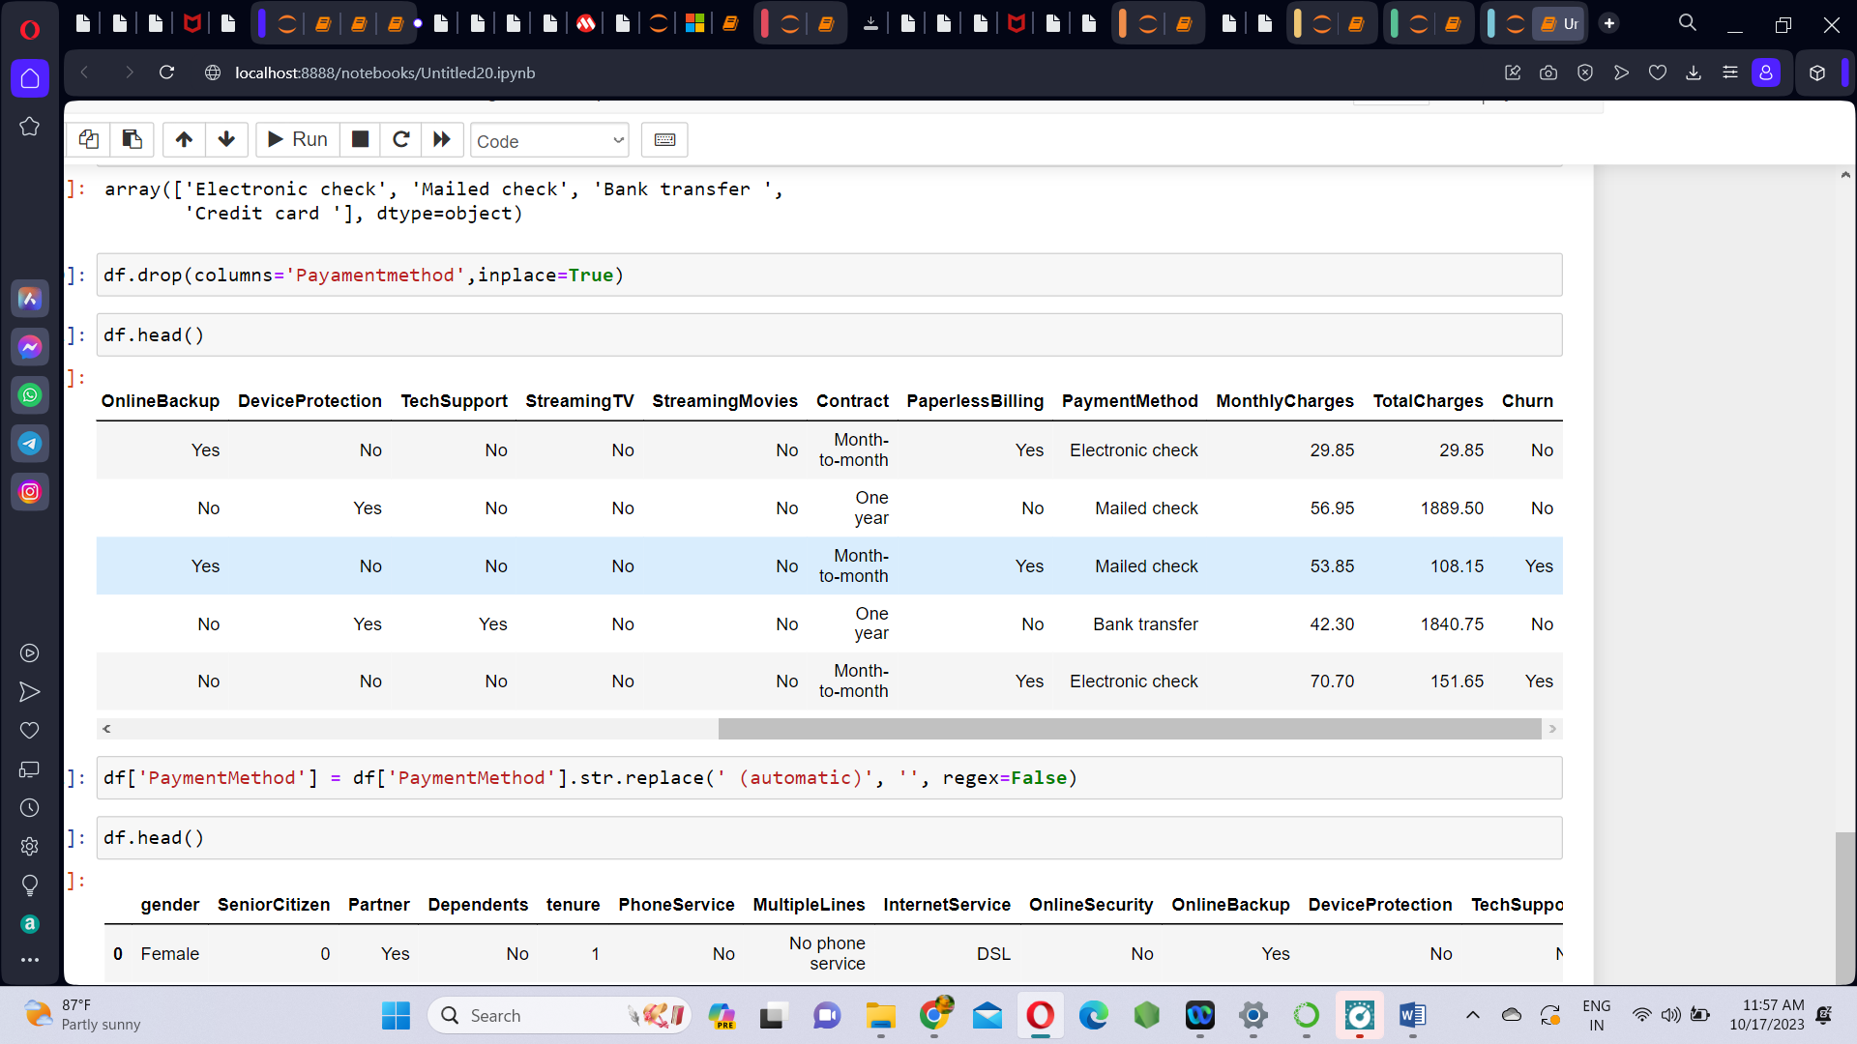

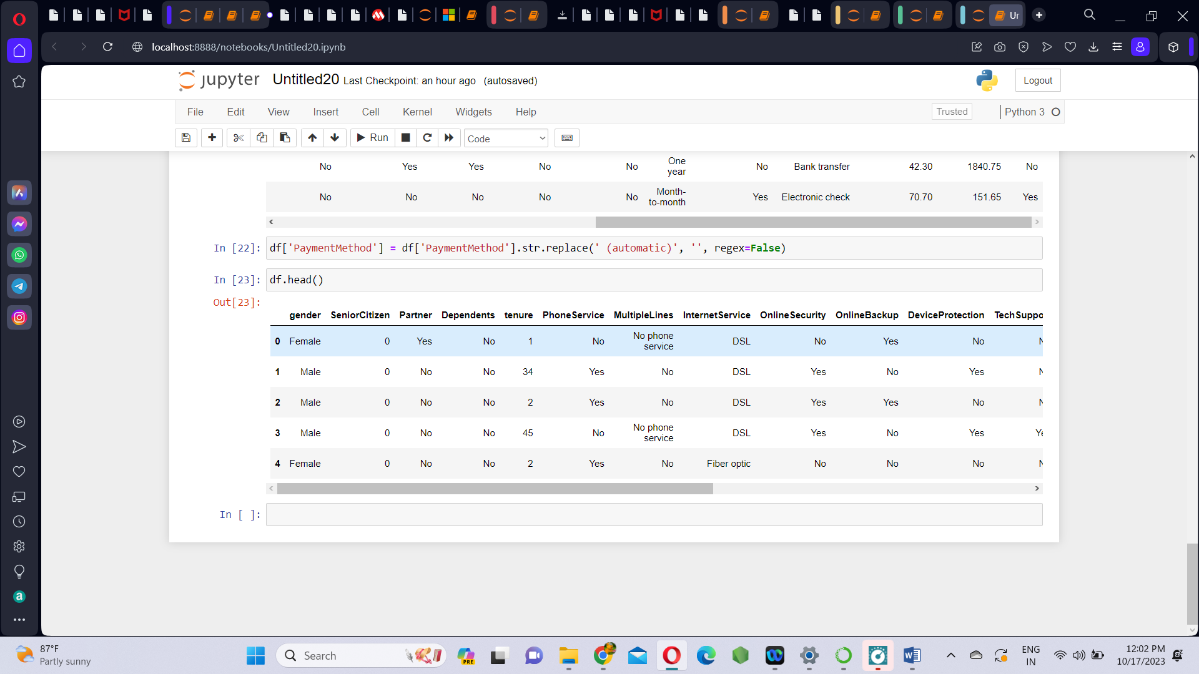

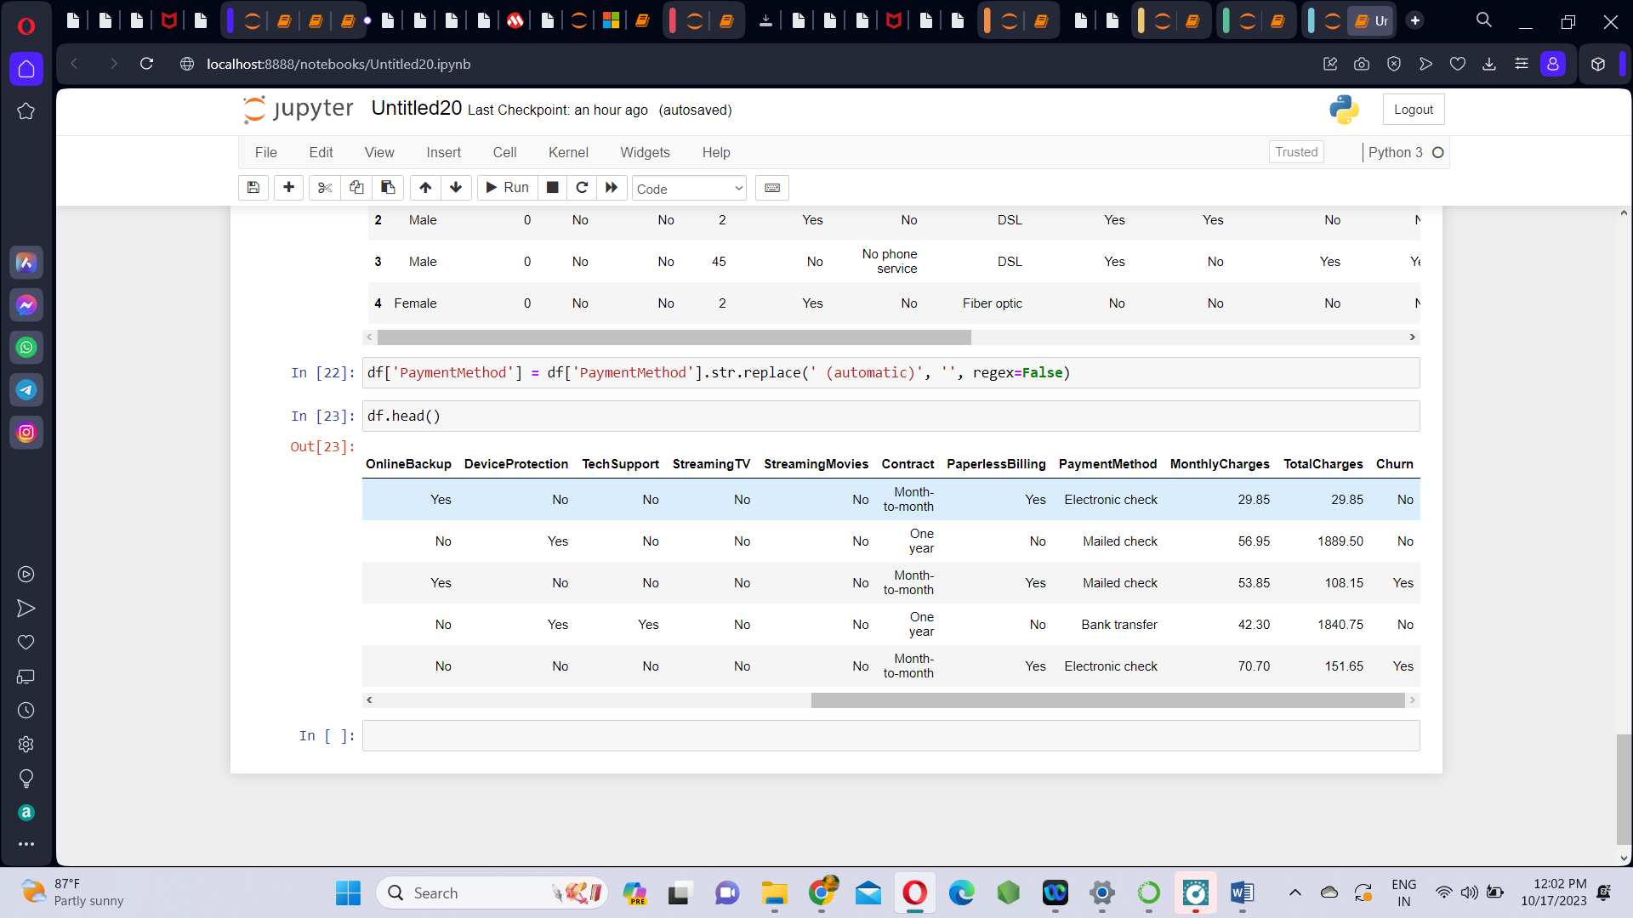

**DATA VISUALIZATION USING IBM COGNOS ANALYTICS:**

We visualize the data in the form of bar plots and stack plots. By this we can understand the relation between various features of the dataset .

1. **Churn Vs Churn(count)**

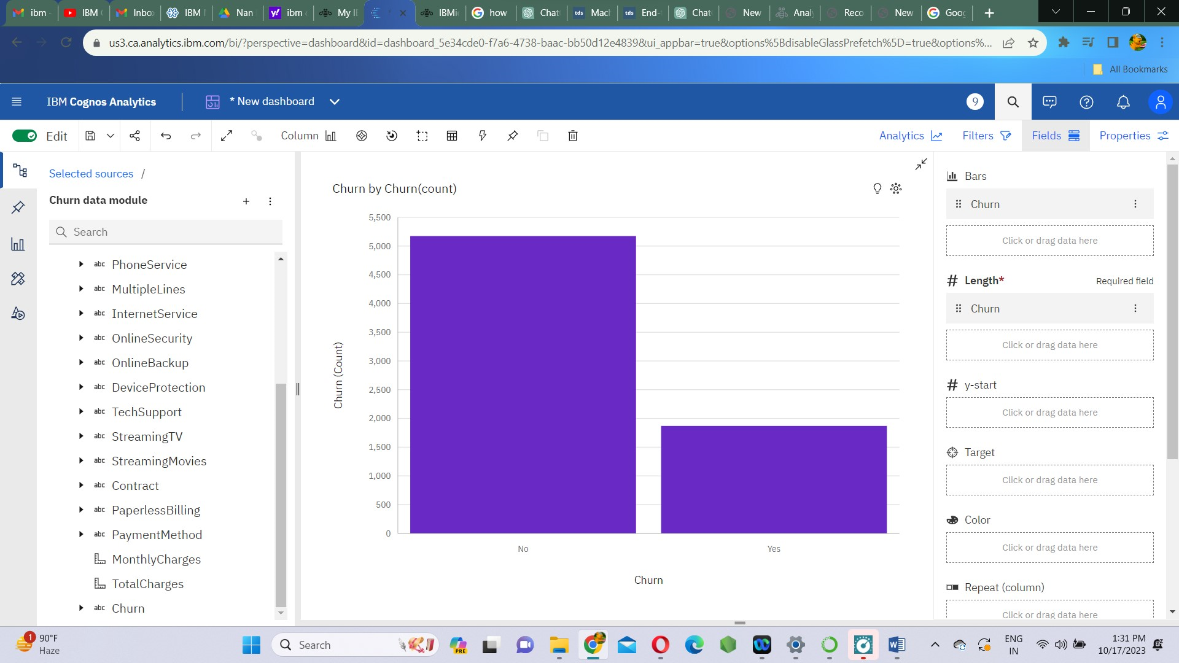

1. **Contract Vs Churn(count)**

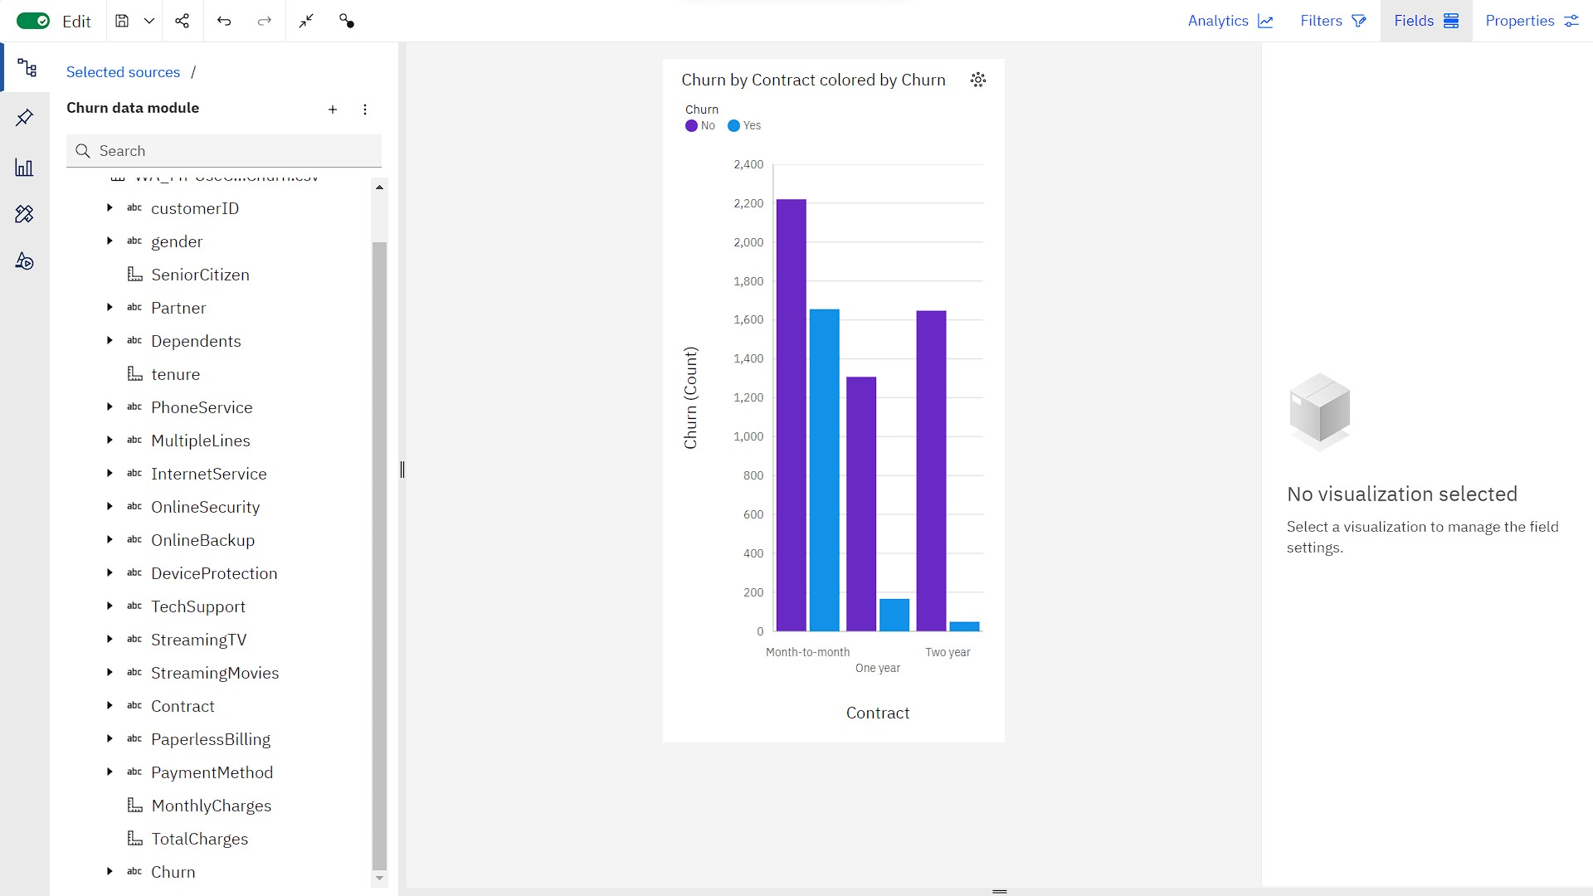

1. **SeniorCitizen Vs Churn(count)**

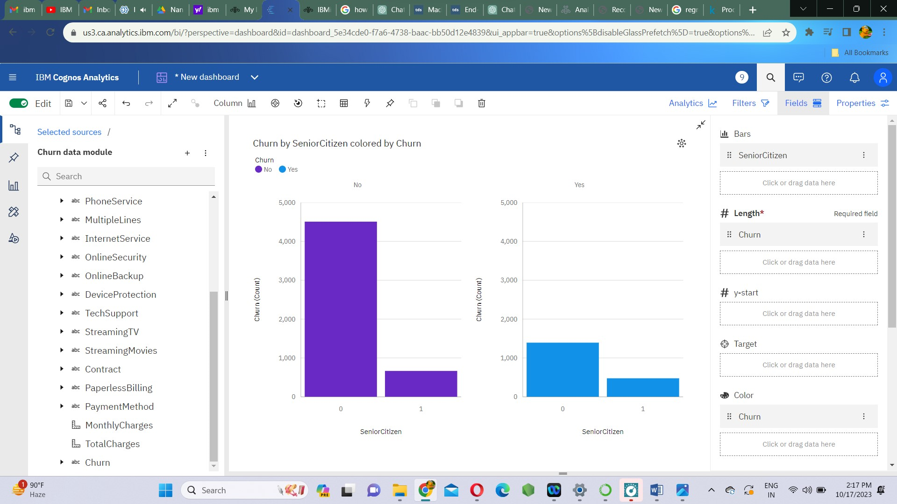

1. **gender Vs Churn(count)**

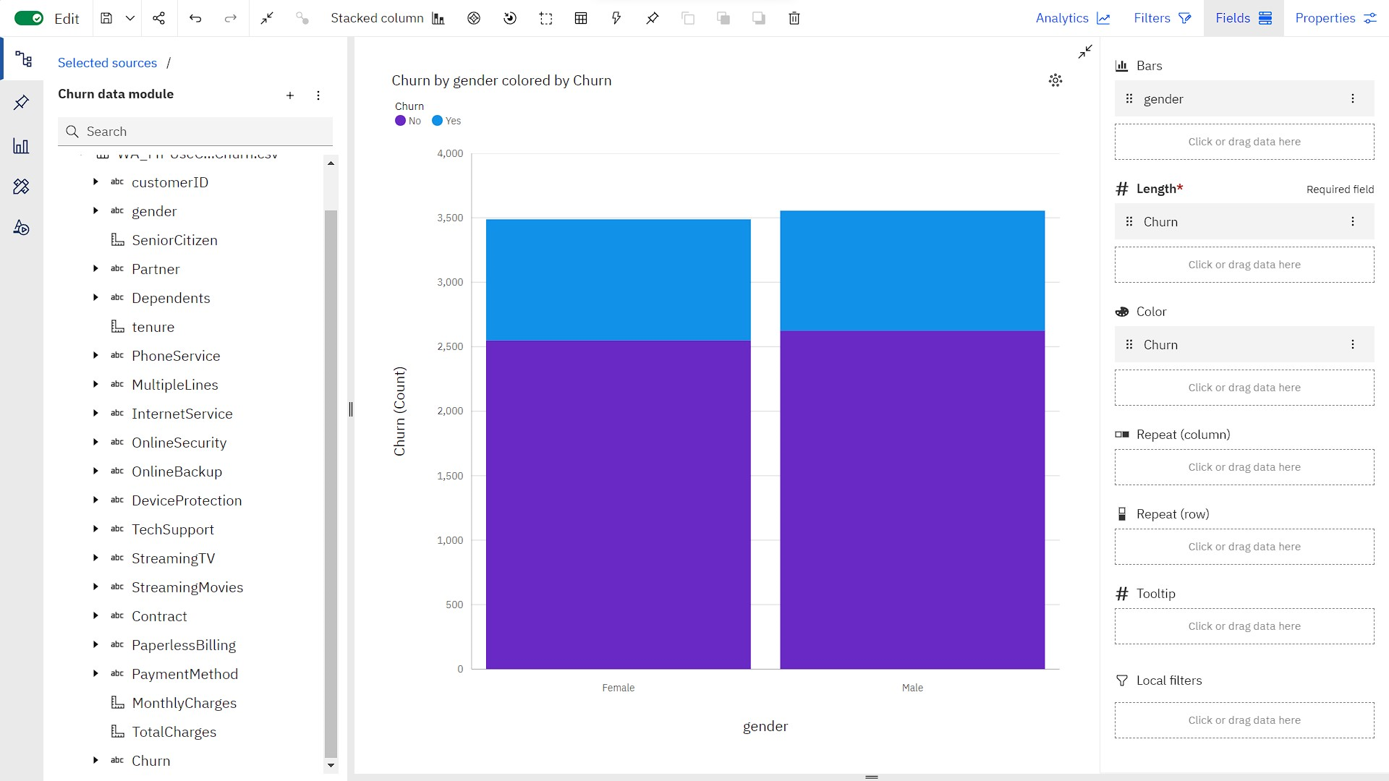

**CATBOOST MODEL**

**Catboost** is a variant of gradient boosting that can handle both categorical and numerical features. It is more efficient when compared to other models like XGBoost, Linear gradient ans so on.

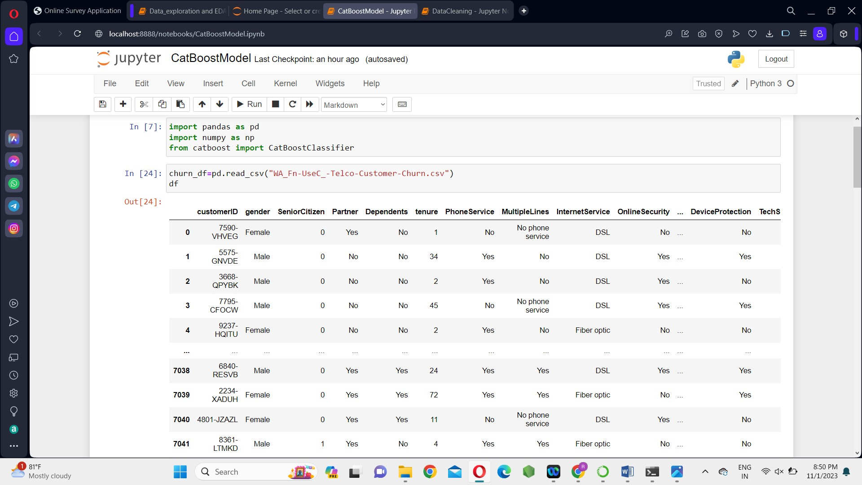





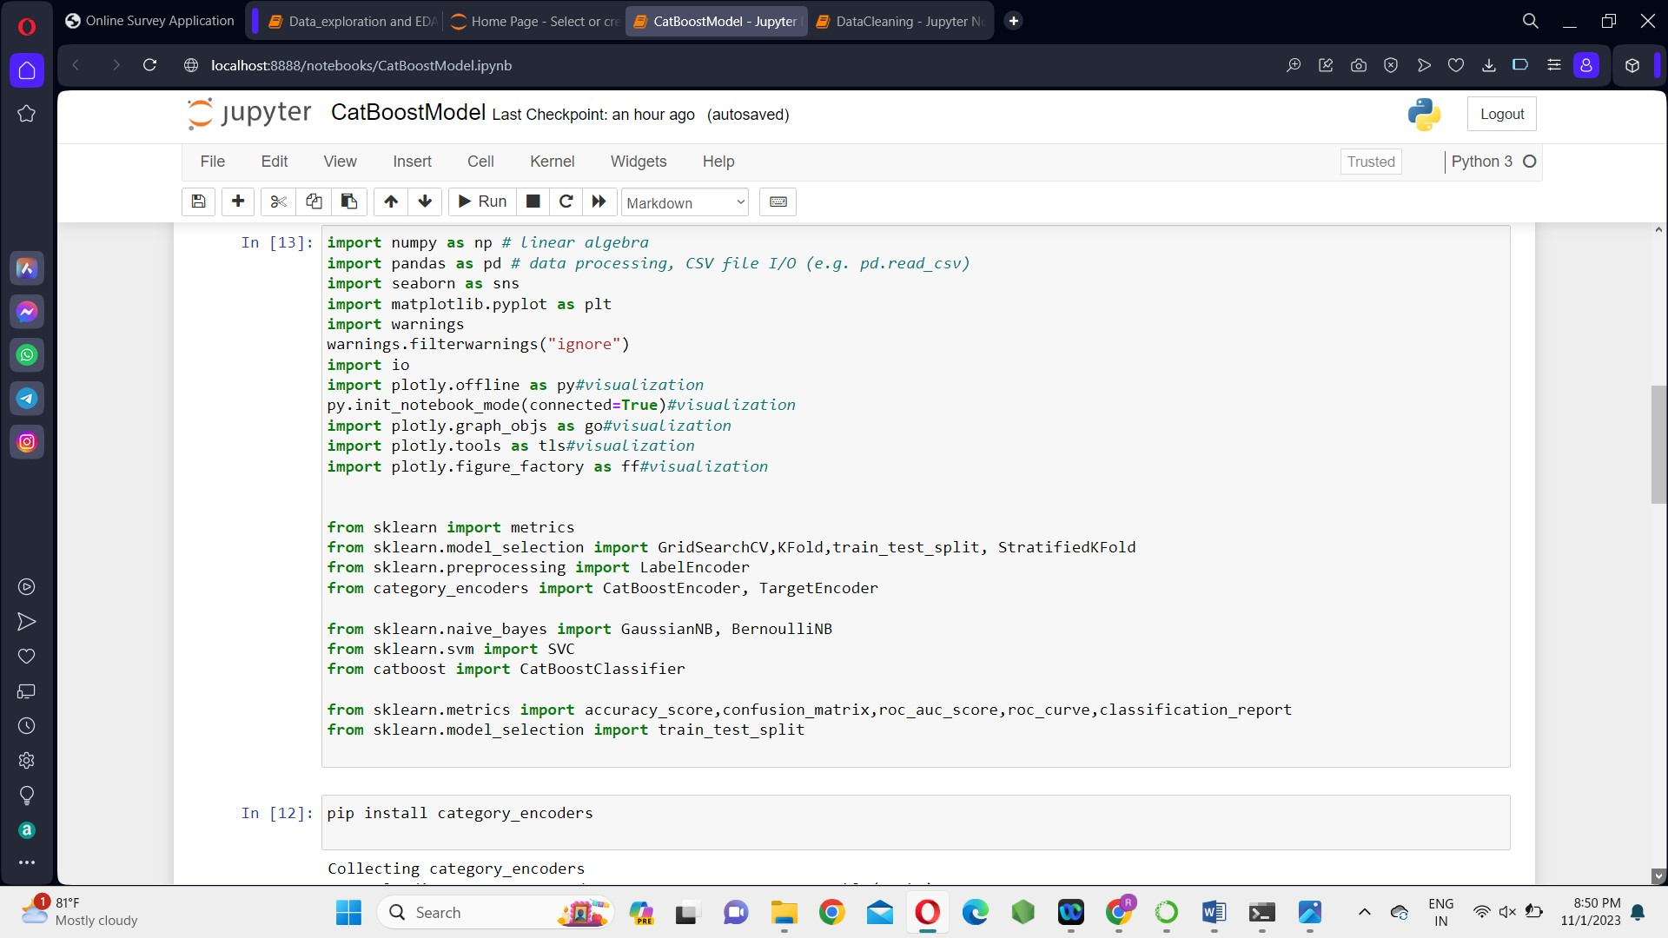



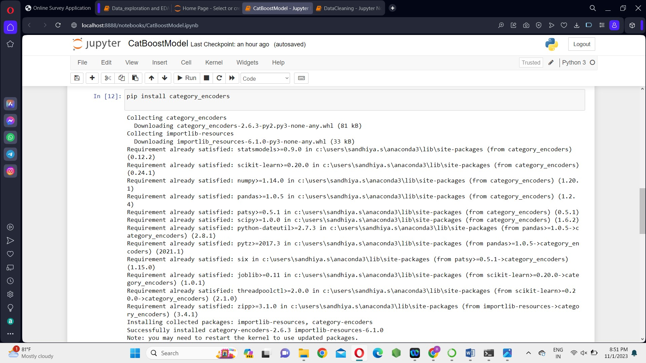

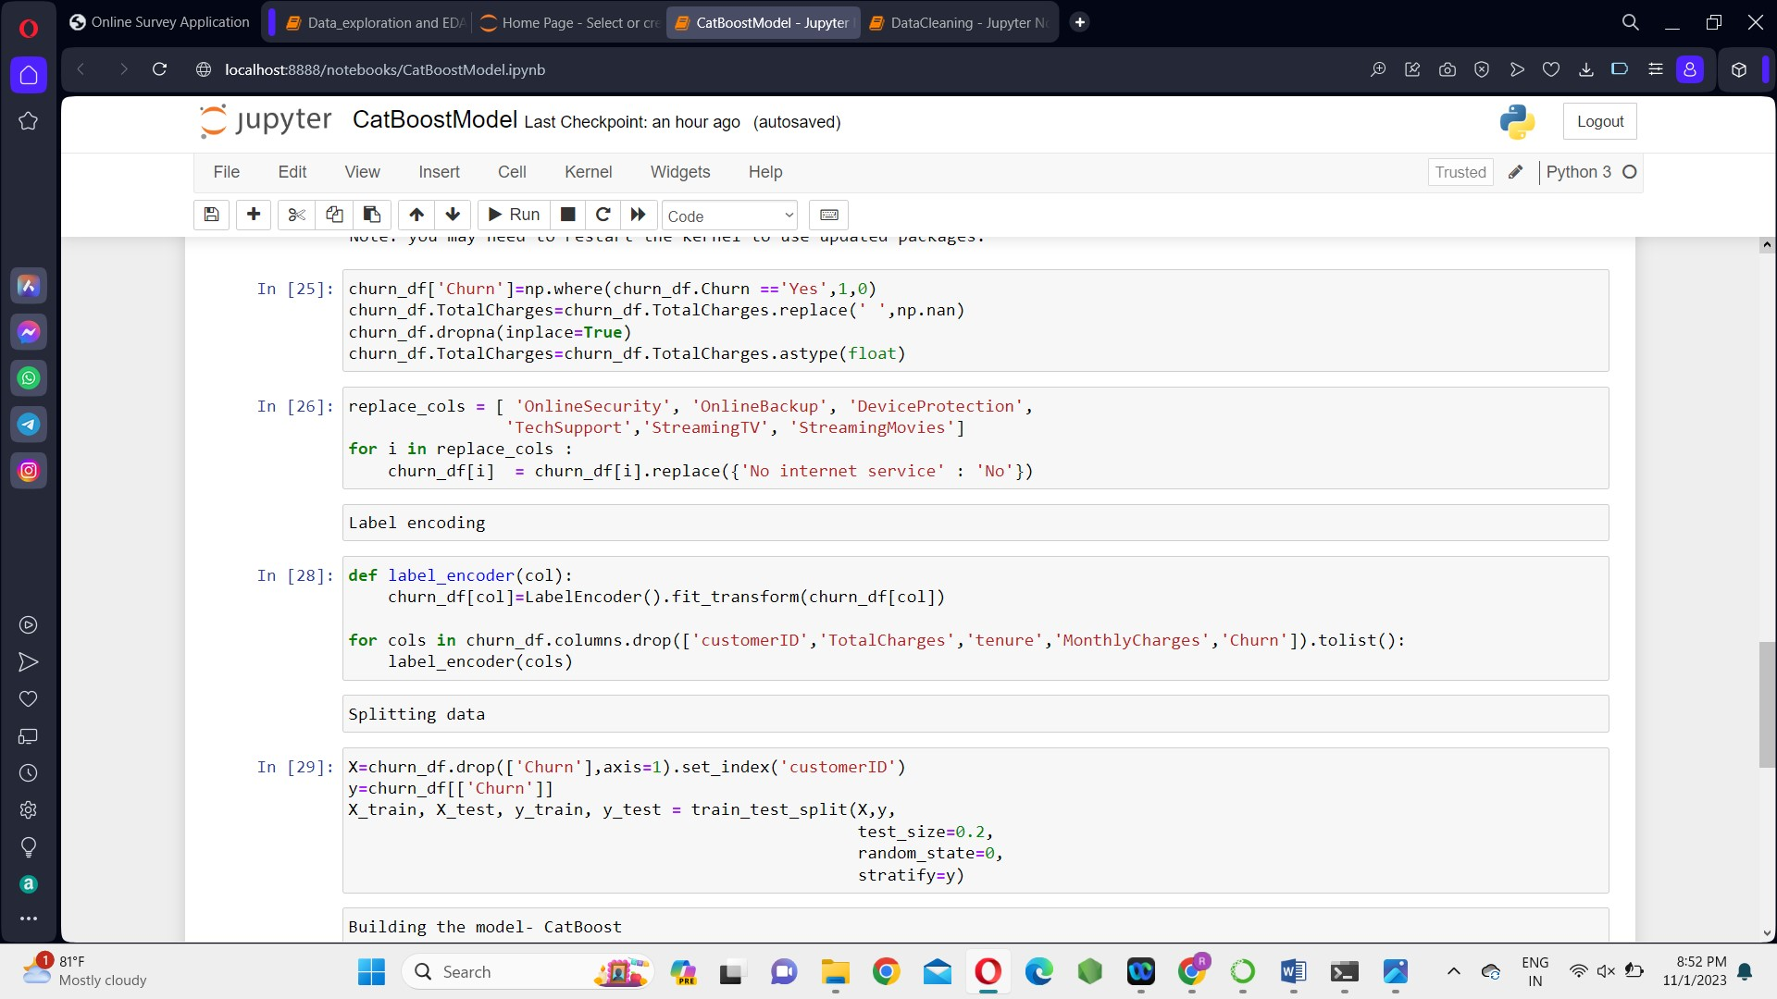

Label Encoding



Data Splitting



Building the model- CatBoost

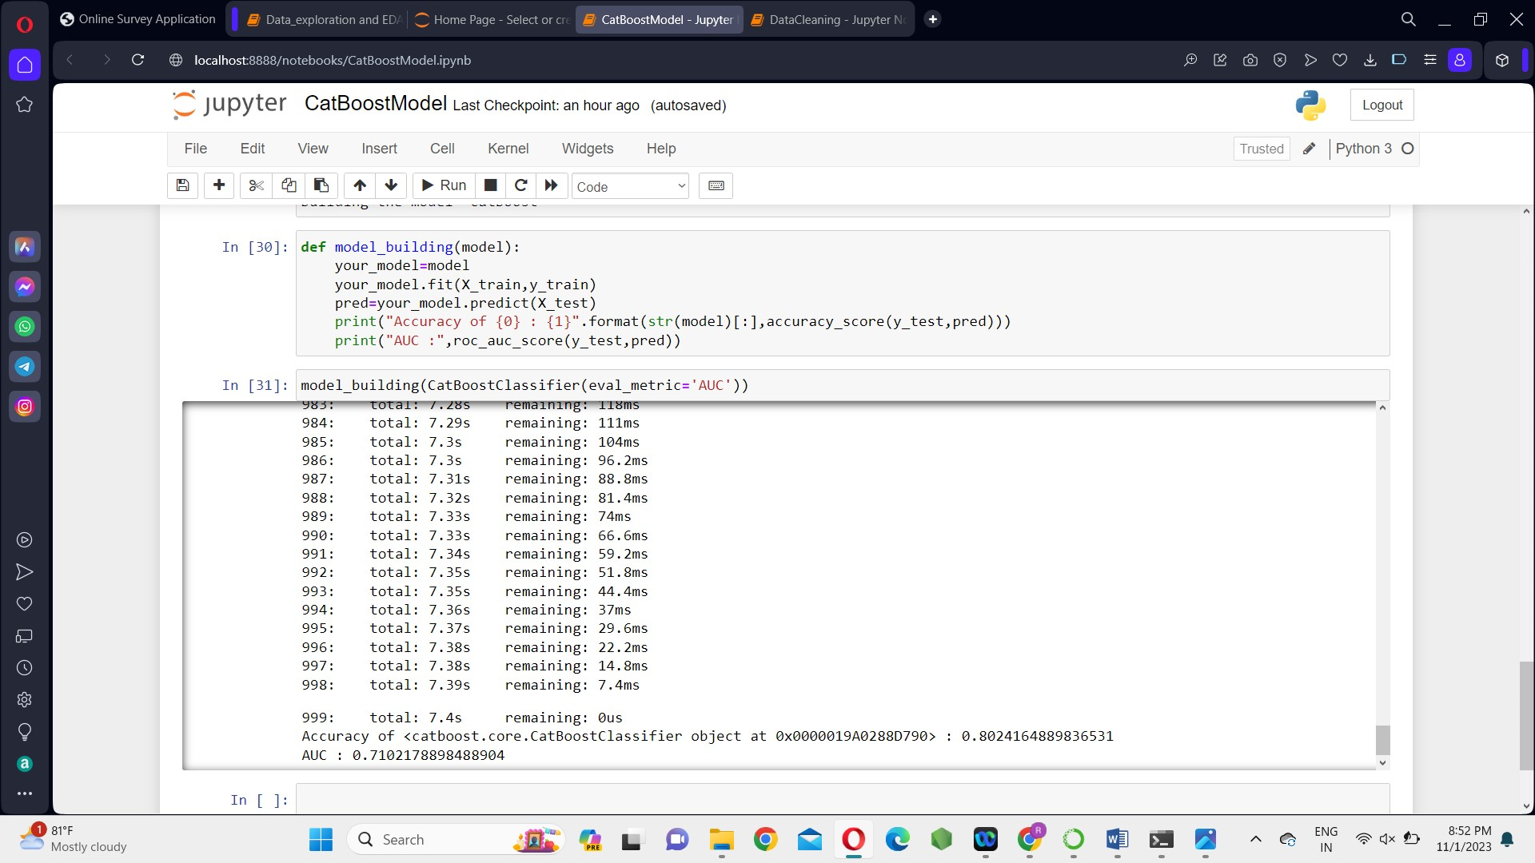



**Hyperparameter tuning:**

After splitting data into a **training set** for **learning the parameters of the model**, and a **testing set** for **evaluating its performance**. The next step in the machine learning process is to perform hyperparameter tuning.

We can implement **random search** in Scikit-learn using the RandomSearchCV class from the sklearn.model_selection package.

**Code:**

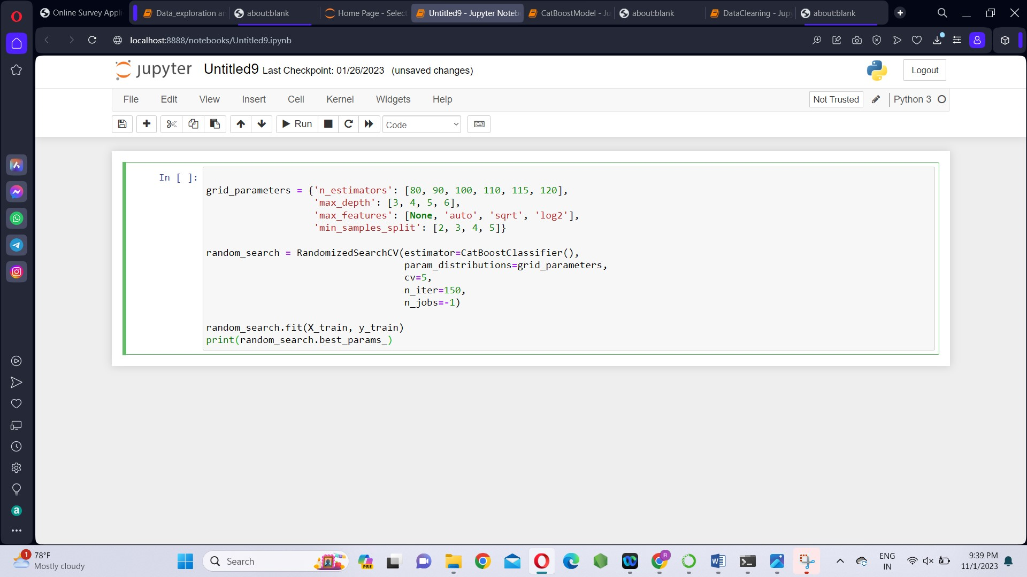

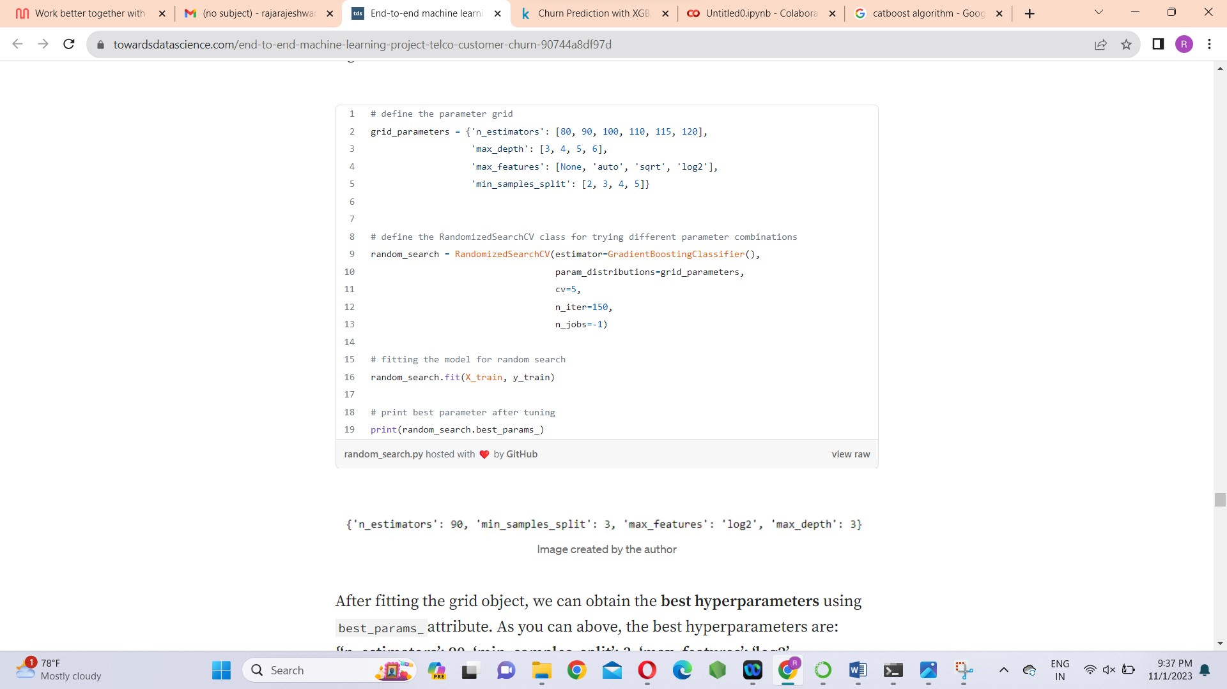

**Conclusion:**

We worked on customer churn prediction in Telecom industry using the given dataset. First, we started with loading the dataset, the Exploratory Data Analysis, data cleaning and the building model- CatBoost. Catboost performs well as compared to other machine learning models like XGBoost, gradient boosting, random forest, and logistic regression.

**Program files:**

**  **

|  |  |
| --- | --- |
| **TEAM ID** | **PROJ_224694_TEAM_2** |
| **TEAM MEMBERS** | **S.RAJARAJESHWARI**  **SANDHIYA.S**  **PRIYADHARSHINI .S**  **KOKILA.U**  **VISHNUPRIYA P** |
| **NAME** | **VISHNUPRIYA P** |
| **REGISTER NUMBER** | **420421205025** |